Job Description template – Leadership & Management

Job Title | Job Grade
Met Office People Leader (Early Careers Meteorologists) | SEO
Profession | Post
Leadership and Management | POST000XXXX
Job Summary & Purpose
Job Summary

The SEO People Leader is a dynamic leadership role responsible for guiding, managing, and developing a team of Early Career Meteorologist (ECM) at the start of their Met Office career guiding them from induction through to qualification and their first permanent role. This job requires excellent people management skills to ensure effective management and performance to drive team growth and success and to deliver on Met Office objectives.
The approach to training and qualification for ECMs is currently under review with People Leaders playing a key role in informing and implementing new ways of working to ensure we provide a rewarding experience for ECMs whilst meeting current and future business needs. They also play a major part in the annual recruitment of new ECMs into the organisation.
The ECM role is fully mobile primarily between our headquarters in Exeter and RAF bases across the country, as such the People Leader role requires regular travel (20% of time) to meet staff face to face and attend meetings. The role will line manage an average of 16 -20 ECMs meeting our internal performance metrics.

Responsibilities

- Leadership - As an enthusiastic leader and role model, manage and lead a team of ECMs such that they are engaged, motivated and inspired as they progress on their training journey with the Met Office, ensuring a consistent employee experience. Embed the business vision and priorities using them to create clear purpose and engagement with our goals. Contribute to the leadership of annual Early Careers recruitment campaigns, induction and onboarding
- Talent Management- Work with the ECMs in your team to ensure that they are developed to support their needs and organisation. Invest time in developing relationships with all team members to understand their motivations and what energises them, unlocking their potential and promoting a culture of development within the team.
- Line management: Build trusted relationships with your team. Develop and implement strategies to enhance employee/team engagement and well-being. Manage attendance effectively and ensure optimal employee experience throughout the whole employee lifecycle. Ensure appropriate recognition, reward and interventions take place based on robust evidence, working closely with local Operational Leads.
- Performance Management : Manage team performance, Ensure clear objectives aligned to Met Office strategy. Hold regular 1:1s and reviews, provide constructive feedback and celebrate success.
- People Leadership - Contribute to the refinement and continuous improvement of the People Leader offer in WIA and to participate in the operations of the People Leader team, working collaboratively, supportively and offering challenge when appropriate.
- Change Management: Lead and manage change initiatives, promoting agility and adaptability within the team. Provide clear contextual understanding of the ‘Why’ and the benefits of change.
- Enabling projects : Either undertake work/projects to benefit your team or key stakeholders, or undertake cross office business projects related to your area of expertise (up to 20% of your time to be flexed in the context of team requirements).

Essential Criteria

- Evidence of being an Expert by Nature by demonstrating your experience of leadership; when and how you have motivated team members in a positive way to develop them

- Show that you are a Force for Good by providing evidence of impactful line management that drives performance including having challenging conversations when required.

- Show that you Keep Evolving with evidence of your willingness to actively engage and contribute towards change, improvement and new ways of working.

- Show that you are Better Together with evidence of working as part of a team to deliver a successful project.
Personal Effectiveness
Our personal effectiveness is defined by our Met Office Values in Action and the Civil Service Success Profiles. The Success Profiles are set out by Civil Service pay grades.
Corporate Effectiveness
Corporate Effectiveness covers the knowledge and expectations of each and every one of us and the content is available on the Corporate Effectiveness - Home Page.

Professional Effectiveness
This post is within the Leadership and Management Profession. The Met Office Leadership and Management Profession has adopted the CMI Standards as its over-arching professional framework.
The CMI Standards defines the technical skills for the assigned Leadership and Management post level, in addition to the Personal and Corporate Effectiveness competencies outlined above. Collectively this sets out the standards and expectations of our Leaders and Managers in the Met Office.
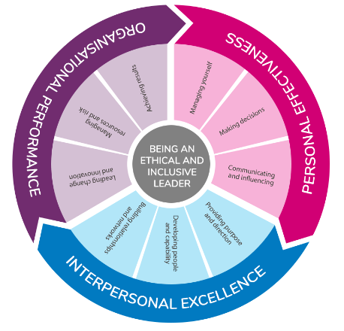 | As a Stage 2 People Leader for Early Career Meteorologists you will need to evidence the relevant skills and competencies applicable to your post as defined by the CMI Standards. Please make yourself familiar with this standards.

Additional Supplementary Information
This job description is not exhaustive, and you may need to undertake other equivalent duties.

